Commands we have learnt -

Ls

Cd directory_name\

Cd .

Cd ..

Ls –a

Ls –A

clear

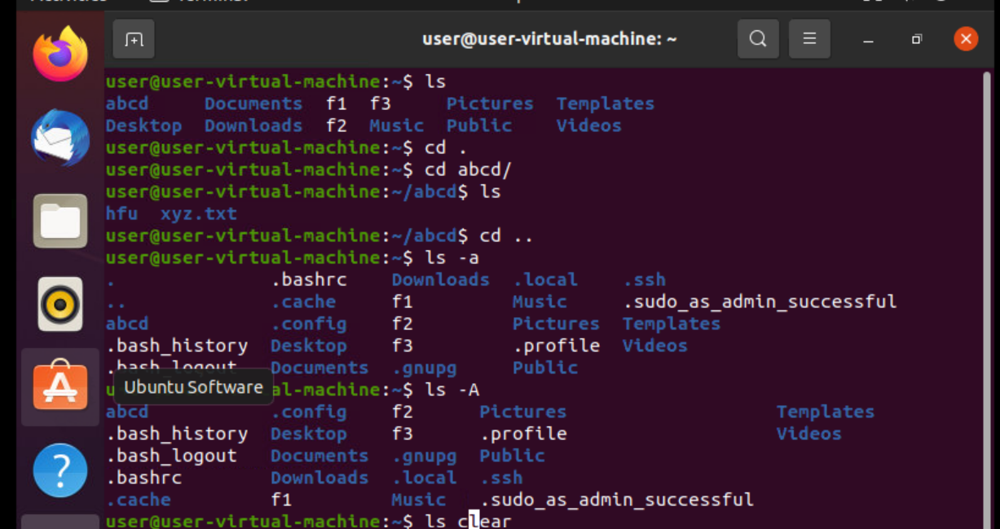

Pwd

Sudo -I

Exit

Ls-l

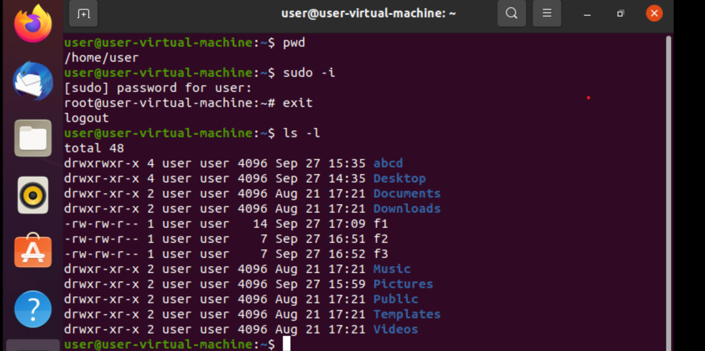

Ls -lh

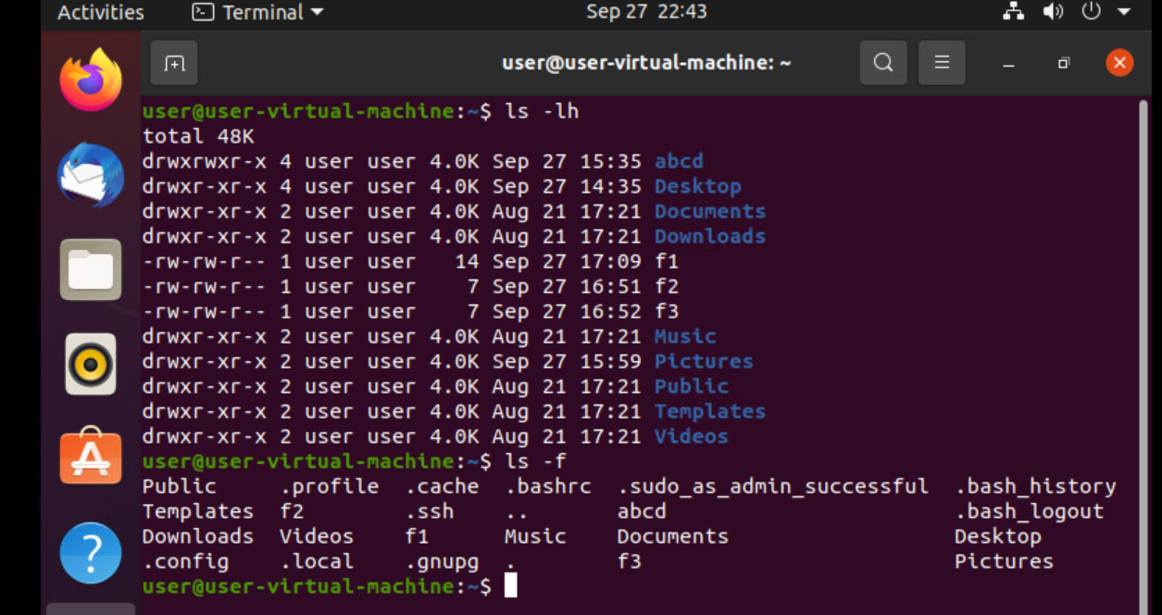

Ls –lt

Ls -ltr

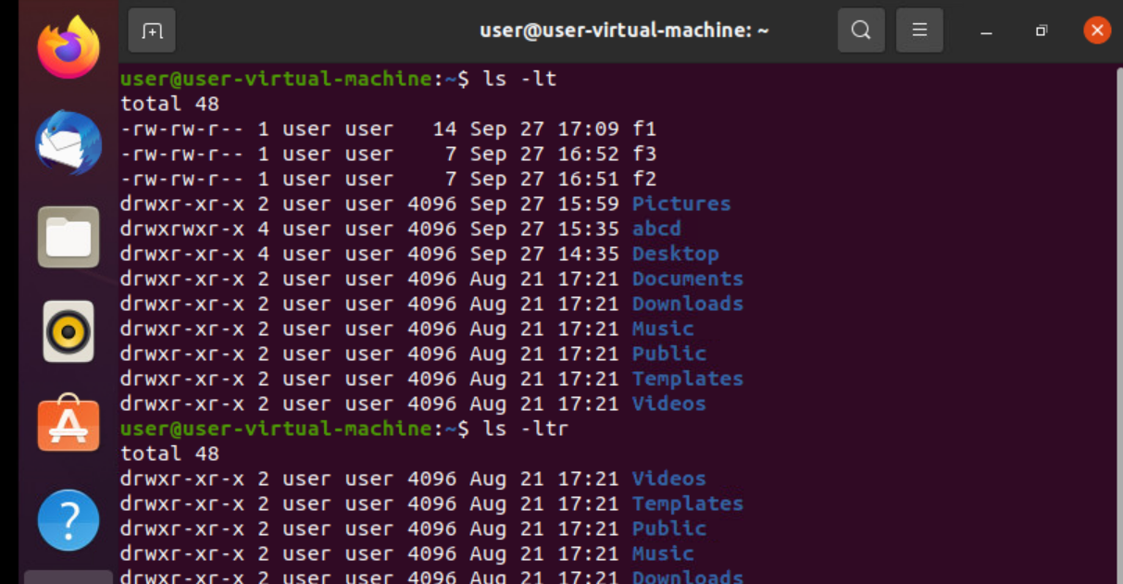

CAT COMMANDS-

Echo

Cat f1

Cat f2>f3(copy)

Cat f2>>f3(append)

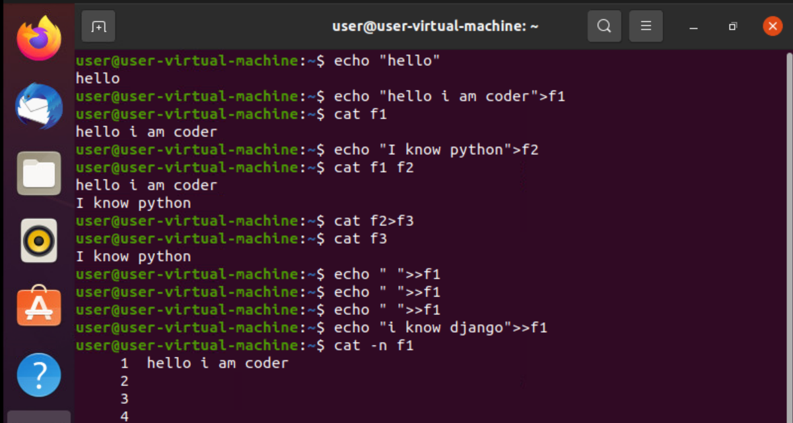

Tac f1(reverse)

Cat –E f1

Cat –t f5

